
Common Security Module
Acegi Security CSM Adapter Design

Version No: 1.0
Last Modified: 05/10/07

Author : Vijay Parmar
Team : Common Security Module
Purchase Order # 34552
Client : National Cancer Institute - Center for Bioinformatics,
National Institutes of Health,
US Department of Health and Human Services

Document History

Document Location
The most current version of this document is located in CVS under c3pr/docs/designs.

Revision History
Version Number | Revision Date | Author | Summary of Changes
0.1 | 5/10/2007 | Vijay Parmar | Initial Draft.

Review
Name | Team/Role | Version | Date Reviewed | Reviewer Comments

Related Documents
More information can be found in the following related CSM documents:

Document Name

Table of Contents
1. Introduction 4
2. Detail Design 4
2.1 Problem Scenario 4
2.2 Requirements 4
2.3 Assumptions 4
2.4 Dependencies 4
2.5 Known Issues or Future Considerations 5
2.6 Proposed Solution 5
2.6.1 Authentication 5
2.6.2 Key Pseudo code/Workflow Diagram 6
2.6.3 New/Modified Classes 6
2.6.4 Database Objects 6
2.6.5 Class Diagram 6
2.6.6 Sequence Diagram 6
2.6.7 WireFrame/Mockups 6
2.6.8 XML Schema, WSDL 6
3. Unit Testing 7
3.1 JUnit Test Cases 7
3.2 Test Case Scenarios 7
4. Configuration/Deployment Considerations 7
4.1 Property/Configuration Files 7
4.2 Deployment Considerations 8

Acegi Security CSM Adapter Design

Introduction

The purpose of this design is to describe the Acegi Security – CSM Adapter design to provide the CSM Authentication and Authorization features via Acegi Security to caCORE SDK.

Detail Design

Problem Scenario

caCORE SDK uses Spring Framework. Acegi Security is the de facto standard for security in Spring Framework. . Current caCORE SDK users are familiar with and utilize Common Security Modules authentication and authorization features. It is a also a requirement for caCORE SDK 4.0 to provide a Acegi Security CSM Adapter that allows SDK to use CSM’s Authentication and Authorization features via Acegi Security Framework.

Requirements

- Provide CSM – Acegi Adapter to integrate CSM with SDK.
- Provide Parameter Level Object security.
- Authentication Requirements
  - Utilize CSM’s JAAS based authentication feature and provide Authentication via Acegi Security.
  - Implement Authentication Interfaces of Acegi to take over authentication logic provided by CSM
  - Provide CSM related Acegi Configuration for Authentication.

- Authorization
  - Authorization includes allowing Object access to Users based on the Method Parameter. Ie. Provide Parameter Level Object Security.
  - Example: public Set search( Criteria criteria). The Method name ‘search’ with parameter ‘Criteria’. The authorization will be based on the User, the method as well as the parameter ‘Criteria’.
  - Provide appropriate Acegi configurations for Authorization.

Assumptions
- SDK will use Acegi Security Framework using Spring Framework.
- Only Parameter Level Object Security is required for this design.

Dependencies

- Acegi Security Framework.
- Spring Framework.
- JAAS

Known Issues or Future Considerations
- Dependency on Acegi Security introduces risk of future release versions that might require changes to the CSM Adapter design and implementation.
- Dependency on spring framework.

Proposed Solution

Acegi Security is widely used within the Spring community for comprehensive security services to Spring-powered applications. It comprises a set of interfaces and classes that are configured through a Spring IoC container. The design of Acegi Security allows many applications to implement the common enterprise application security requirements via declarative configuration settings in the IoC container. Acegi Security is heavily interface-driven, providing significant room for customization and extension. Important Acegi Security, like Spring, emphasizes pluggability.

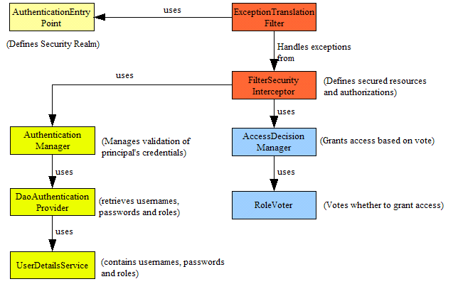

Figure 1.1 Authentication and Authorization in Acegi.

Figure 1.1 demonstrates the control flow by Acegi for authentication and authorization. The Proposed solution uses this approach to provide CSM Adapter.. Authenticaton Design is cby extending this design Acegi provides Interceptors which can be configured through Acegi Security Configurations in Spring.

Authentication

The major interfaces and implementations of Acegi Security's authentication services are provided in Figure 1.2. The central interface is Authentication, which contains the identity of the principal, its credentials, and the GrantedAuthoritys the principal has obtained. GrantedAuthority is an interface and implementations can have any meaning appropriate to the application. CSM implements this Interface in CSMGrantedAuthorityImpl class to store a String representation of an authority the principal has been granted.

The AuthenticationManager is the central interface responsible for processing an Authentication "request" object and determining if the presented principal and credentials are valid. If they are valid, the AuthenticationManager populates the Authentication with the GrantedAuthoritys that apply. The main implementation of AuthenticationManager is known as ProviderManager, which is responsible for polling a list of AuthenticationProviders.

The ProviderManager uses the first AuthenticationProvider capable of processing a given Authentication request object. Most of the time the DaoAuthenticationProvider is used to process an authentication request. Figure 10-2 provides a class diagram for this important provider. As shown, DaoAuthenticationProvider will retrieve a UserDetails from an AuthenticationDao. DaoAuthenticationProvider also provides other useful features such as caching layer integration and decoding of encoded passwords (for example, SHA or MD5 with salts).

For Authentication, CSM will extend the AbstractUserDetailsAuthenticationProvider abstract class which implements the AuthenticationProvider Interface to provide its custom DaoAuthenticationProvider that uses CSM’s underlying JAAS based authentication Login Modules. CSM Implements UserDetailsService that retrieves usernames, passwords and GrantedAuthorities (roles). Implement the UserDetailsService Interface provided by Acegi.

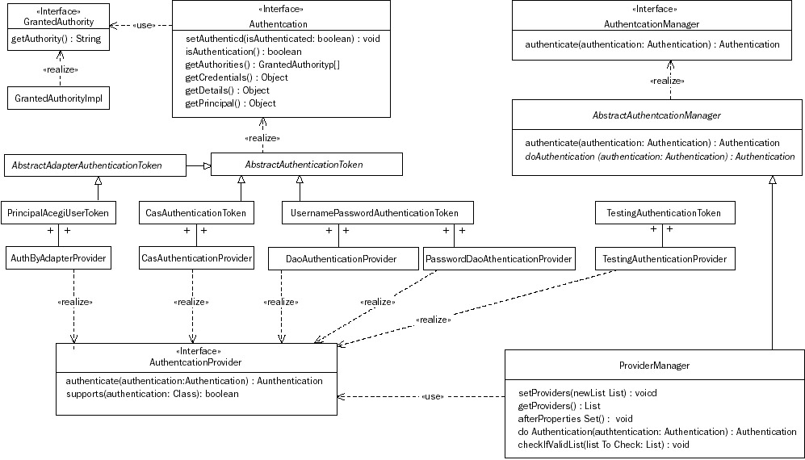

Authorization

Once the user is authenticated, the Authentication object is stored between requests and made available through the ContextHolder.

Figure 1.2 provides an overview of the key authorization interfaces and classes. An important interface is ConfigAttribute, which represents a configuration setting that applies to a secure object invocation Configuration attributes are similar to Spring's transaction attributes, such as PROPAGATION_REQUIRED.

The AccessDecisionManager is responsible for making an authorization decision. It is passed the secure object, in case it needs access to properties of the secure object invocation such as arguments in the case of a MethodInvocation. The AccessDecisionManager is also passed the configuration attributes that apply to the secure object invocation, along with the validated Authentication object. This information is sufficient to make an authorization decision by returning void or throwing an AccessDeniedException.

Similar to the authentication-related ProviderManager, the AbstractAccessDecisionManager adopts a provider-based approach whereby it will poll a series of AccessDecisionVoters. Each voter returns a veto, grant, or deny vote. The final decision based on these votes is left to the specific AbstractAccessDecisionManager implementation.

The RoleVoter is the most commonly used AccessDecisionVoter with Acegi Security. It iterates through each configuration attribute, voting to grant access if one matches a GrantedAuthority held by the principal

In order to actually authorize a secure object invocation, Acegi Security needs to intercept the invocation to begin with.

CSM will implement the AccessDecisionVoter Interface in CSMAccessDecisionVoter Class. This custom implemented class will examine the Search methods ‘Criteria’ parameter. It will try to match the GrantedAuthorities with the Criteria type. If a match is found, the user is authorized to invoke the method.

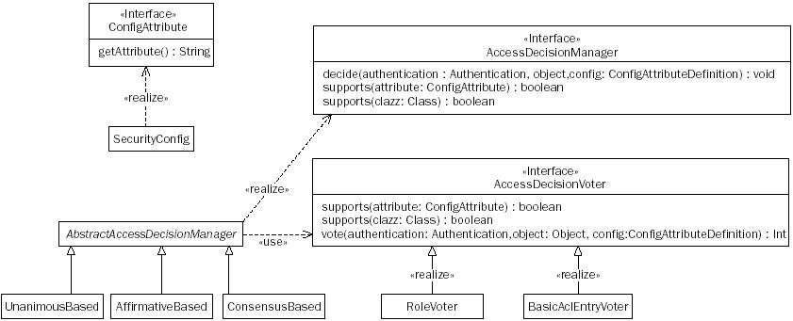

New (*) or Modified (#) | Package Name | Class/Interface Name | Method Name | Description
* | gov.nih.nci.security.acegi.authentication | CSMUserDetailsService |  | For Authentication.
* | gov.nih.nci.security.acegi.authentication | CSMUserDetails |  | For Authentication.
* | gov.nih.nci.security.acegi.authentication | CSMDaoAuthenticationProvider |  | For Authentication.
* | gov.nih.nci.security.acegi.authentication | CSMGrantedAuthority |  | For Authentication.
* | gov.nih.nci.security.acegi.authentication | User |  | For Authentication.
* | gov.nih.nci.security.acegi.authorisation | CSMAccessDecisionVoter |  | Implements the AccessDecisionVoter
*

Key Pseudo code/Workflow Diagram
N/A

New/Modified Classes

* The description should be javadoc for the class if a new class or javadoc for a method for method level changes.

Database Objects
N/A

Class Diagram

Figure 1 Class Diagram

Sequence Diagram

WireFrame/Mockups
N/A

XML Schema, WSDL

N/A

Unit Testing

JUnit Test Cases
Instruction: List and provide a description of the new, modified, or existing JUnit Test Case classes that will be utilized to unit test the enhancement.

New (*) or Modified (#) | Package Name | Class/Interface Name | Method Name | Description
* |  |  |  | .

* The description should be javadoc for the class if a new class or javadoc for a method for method level changes.

Test Case Scenarios
Instruction: Describe scenarios other than JUnit Tests that are used to unit test the enhancement resulting from this design.

Configuration/Deployment Considerations

Property/Configuration Files
Instruction: List all property files and configuration files that will be changed as a result of this design in the table below, including launch HTML or changes to web forms config files.

New (*) or Modified (#) | File Location | File Name | Description of Change
# | <SDK-APPLICATION>/WebRoot/WEB-INF | web.xml, | In the web.xml, the application will need a single Acegi Security filter in order to use the FilterChainProxy. Nearly every Acegi Security application will have such an entry,
* | <SDK-APPLICATION>/WebRoot/WEB-INF | applicationContext-acegi-security.xml | The Acegi Configuration file.

Deployment Considerations

As part of deployment process the JBOSS_HOME/server/default/conf/login-config.xml needs to be modified to include an application-policy for ‘sdk’ authentication.

